Overview
The Claim for travel expenses page allows you to lodge a claim for reimbursement of travel expenses including accommodation incurred in attending an approved medical appointment relating to a condition for which the department has accepted liability.

The Claim for travel expenses screen.
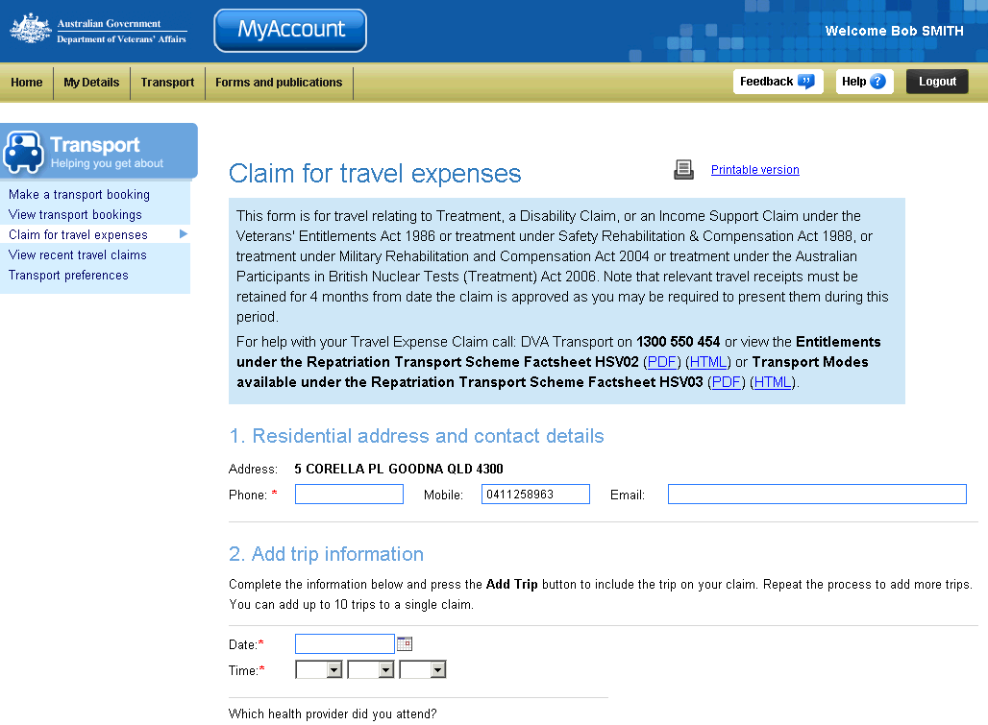
Five steps to make a claim
Transport menu
Help information and fact sheets
 | For VEA clients - When making a claim for travel expenses through MyAccount you are asked for the same information as is requested on the paper claim form (D800 form).

When making a claim, fields marked with a red asterisk (*) are mandatory.

Make a claim for travel expenses
To make a claim for travel expenses:
- In the 1 Residential address and contact details section, in the Phone field, enter your contact phone number.
In the Address field, your residential address, as displayed in MyAccount, appears by default.
- In the 2. Add trip information section, in the Date field, enter the date of your medical appointment.
When entering dates, you can use the calendar tool ( ) to select a date from a calendar. Alternatively, enter dates in the format dd/mm/yyyy.
- In the Time fields, use the drop down boxes to select the hour, minutes and ‘am’ or ‘pm’ time of your medical appointment.
- From the Provider type drop down list, select the type of medical provider you met with.
If you choose the Provider type ‘Other’, a new field displays.
In the Enter provider type field, enter the type of medical provider you met with (for example, Cardiologist, Dermatologist, etc).
- In the Name, Suburb, Postcode and State fields, enter the medical providers name and address information.
- From the What is this trip for? drop down list, select the reason for the medical appointment.
- In the Is the treating provider the closest practical provider….? drop down list, select Yes or No.
- In the Reason/s for this visit field, enter a description of the visit you are claiming travel reimbursements for.
- In the What are you claiming? section, enter amounts for the return trip distance travelled by private vehicle (if any) and travel expenses.
Claims cannot be lodged through MyAccount where the return trip distance is more than 100km.
In these circumstances, you must complete a paper ‘D800 Claim for Travel Expenses’ form.
- For the Did DVA arrange/pay for this travel…? drop down list, select Yes or No.
- For the Do you require accommodation? drop down list, select Yes or No.
- By selecting yes to requiring accommodation, you are required to complete:
- accommodation type
- how many nights
- For the Did you travel with an attendant? drop down list, select Yes or No.
- For the Did you share accommodation with your attendant? drop down list, select Yes or No.
- Click on the Add Trip button.

The Claim for travel expenses screen updates.
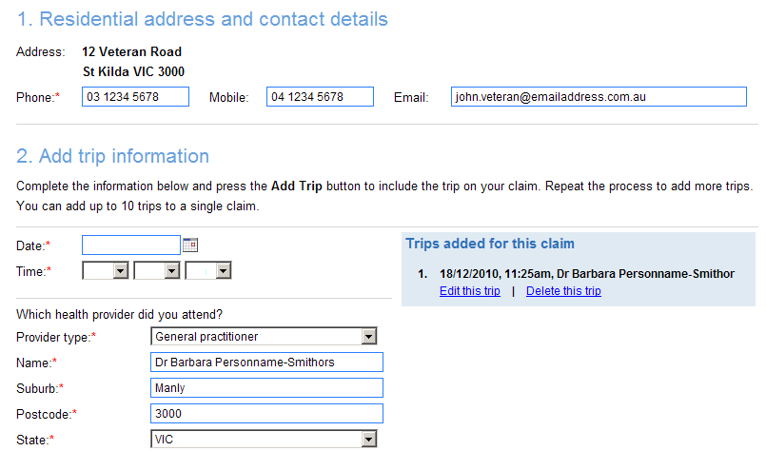
Trips added box
A brief summary of the trip is displayed in the blue Trips added for this claim box to the right of the screen in the 3. Add trip information section.
- Repeat Steps 3 to 10 for each trip you want to add to the claim.
- In the Additional information section, enter any additional information that you believe may be relevant to or will assist with your claim.
Information you may wish to provide, for example: why it was necessary to use your own vehicle; why you had to visit a particular health provider.
- In the Declaration section, select the check box.
If you are ready to submit your travel expenses claim, go to the Submit a claim section of this document, below.

Edit / delete a trip added to a claim
Prior to submitting a claim, you can change the details for, or delete, a trip you have added to the claim.
To edit or delete a trip added to a claim:
- Identify the trip in the blue Trips added for this claim box displayed to the right of the screen in the 3. Add trip information section.

The Trips added for this claim box.
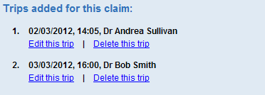
To edit a trip, go to Step 2.
To delete a trip, go to Step 5.

Edit a trip
- Click on the Edit this trip link.

The 3. Add trip information section updates with the trip details displayed.
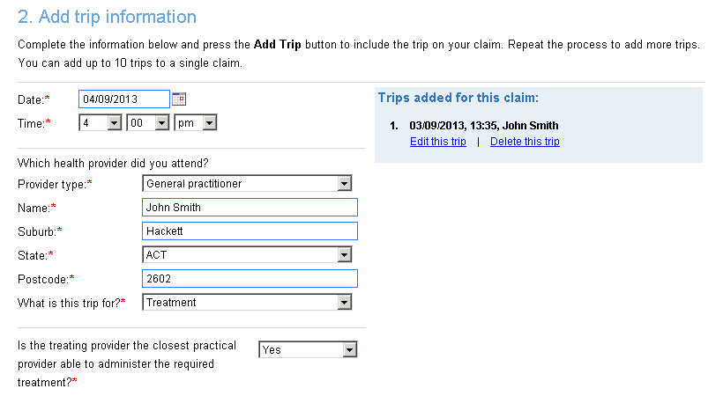
- Edit the details in the 3. Add trip information section as required.
- At the bottom of the section, click on the Save Trip button.
The Claim for travel expenses screen updates, ready to add another trip.

Delete a trip
- Click on the Delete this trip link.

A confirmation dialog box displays.
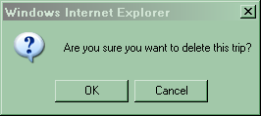
- Click on the OK button.
The Claim for travel expenses screen updates. The trip is deleted from the Trips added for this claim box.

Save a claim as a draft
If you are not ready to complete and submit your travel expenses claim (for example, you want to add additional trips later), you can save your claim as a draft.
- To save the claim as a draft, click on the Save as draft button.

The save draft dialog box displays.
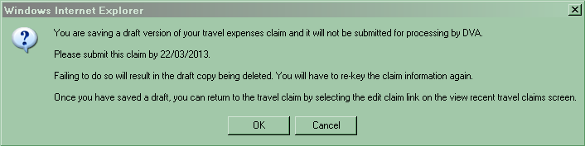
- Click on the OK button.

The View recent travel claims screen displays.
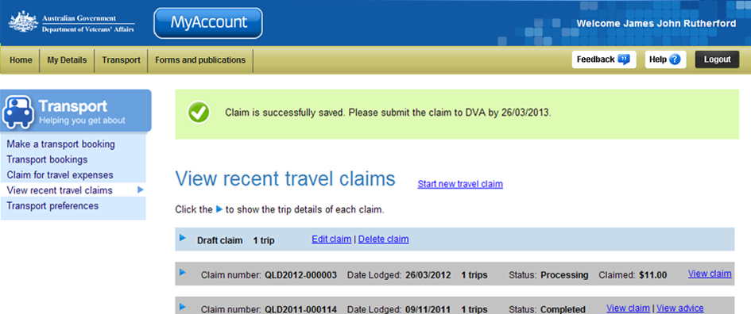
At the top of the screen, a green success message states your claim has been successfully saved.
The date your draft claim must be submitted by is also displayed.

Edit / load a saved draft claim
If you have a travel expenses claim you previously saved as a draft, you can load / edit the draft claim from either the View recent travel claims screen or the Claims for travel expenses screen.

The Claim for travel expenses screen – with a saved draft travel claim.
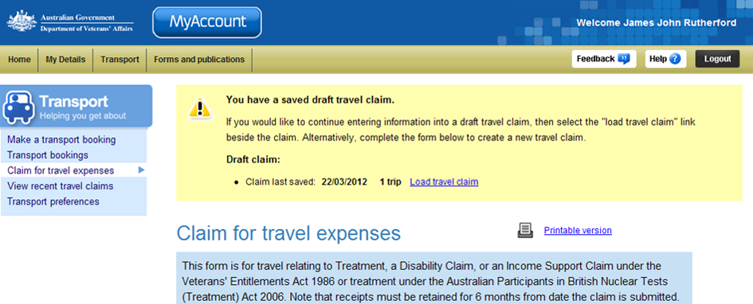
Saved draft travel claim information
To load/edit a saved draft travel expenses claim, from the Claim travel expenses screen, click on the Load travel claim link.

Submit a claim
To complete and submit a travel expenses claim, click on the Submit claim button at the bottom of the screen.

The View recent travel claims screen displays.
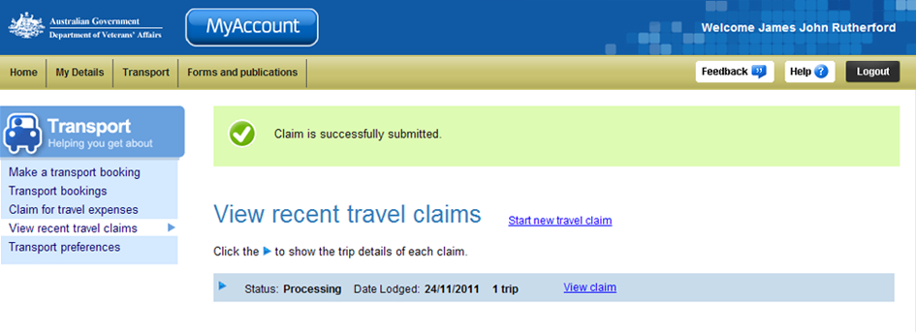
At the top of the screen, a green success message states your claim has been successfully submitted.

Other functions
 | To view another section or perform another transaction related to transport, click on a link in the Transport menu to the left of the page.
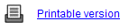 | To print a copy of the information displayed on this page, click on the Printable version link.
 | To get additional help with the Claim for travel expenses screen, click on the Help button at to the top right of the page.
 | When you are finished using MyAccount, to log out and finish using the service in a secure way, click on the Logout button.

